Project Two
NetShield: ASG–NSG Driven Multi-Tier Security Architecture in Microsoft Azure

1. Project Introduction
In modern cloud environments, security is no longer limited to perimeter firewalls. Applications are deployed across multiple tiers—web, application, and database—each with different security requirements. Improper network access control between these tiers can lead to data breaches, lateral movement attacks, and unauthorized access.
NetShield is a hands-on Azure security project that demonstrates how to design and implement a secure multi-tier architecture using Network Security Groups (NSGs) and Application Security Groups (ASGs). The project focuses on layered defense, network segmentation, and controlled traffic flow between application tiers.
This project simulates a real-world enterprise setup where:
- The Web tier communicates only with the Application tier
- The Application tier communicates with the Database tier
- Direct access to the database from the web tier is strictly blocked
- Monitoring and alerting are enabled to detect abnormal resource usage

2. Project Objectives
The primary objectives of the NetShield project are:
- To design a secure three-tier architecture in Azure.
- To understand and implement Virtual Networks (VNETs) and subnets.
- To configure Network Security Groups (NSGs) to restrict traffic flow.
- To use Application Security Groups (ASGs) for scalable and flexible security rule management.
- To test and validate security rules using real VM traffic.
- To implement monitoring and alerting using Azure Monitor.
- To analyze system metrics and logs for operational visibility.

3. Architecture Overview
Architecture Components
- Resource Group – Logical container for all resources
- Virtual Network (VNET) – Private network for communication
- Subnets
  - Web Subnet
  - App Subnet
  - DB Subnet
- Virtual Machines
  - Web VM (Ubuntu)
  - App VM (Ubuntu)
  - DB VM (Ubuntu)
- Security
  - Network Security Groups (NSG)
  - Application Security Groups (ASG)
- Monitoring
  - Azure Monitor
  - Alerts (CPU-based)
Traffic Flow Design
Source | Destination | Allowed | Reason
Web VM | App VM | Yes | Application access
Web VM | DB VM | No | Prevent direct DB exposure
App VM | DB VM | Yes | Backend data access
Any VM | Internet | Controlled | Security best practice

4. Implementation Steps

Step 1: Create a Resource Group
- Log in to Azure Portal
- Navigate to Resource Groups
- Click Create
- Enter:
  - Resource Group Name: project-2-rs
  - Region: Canada Central (or preferred region)
- Click Review + Create
Purpose:
To logically organize all project resources for easy management and cleanup.
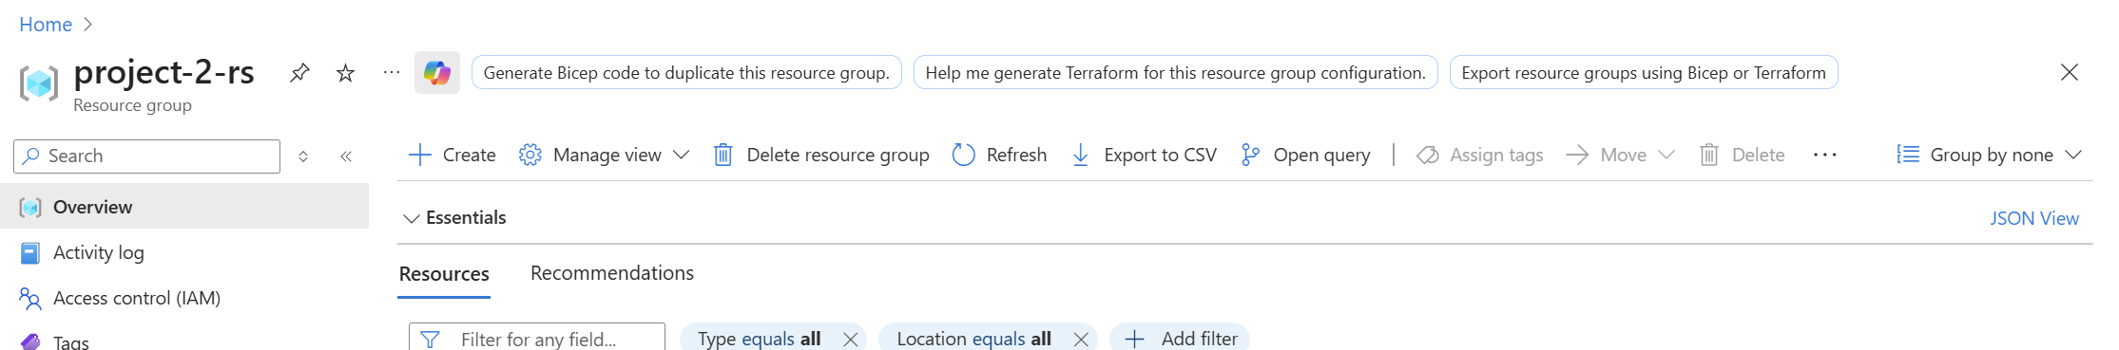

Step 2: Create a Virtual Network with Subnets
- Go to Virtual Networks → Create
- Provide:
  - VNET Name: NetShield-VNET
  - Address Space: 10.0.0.0/16
- Create the following subnets:
Subnet Name | Address Range
web-subnet | 10.0.1.0/24
app-subnet | 10.0.2.0/24
db-subnet | 10.0.3.0/24
- Review and create the VNET
Purpose:
To separate application tiers using subnet-level isolation.
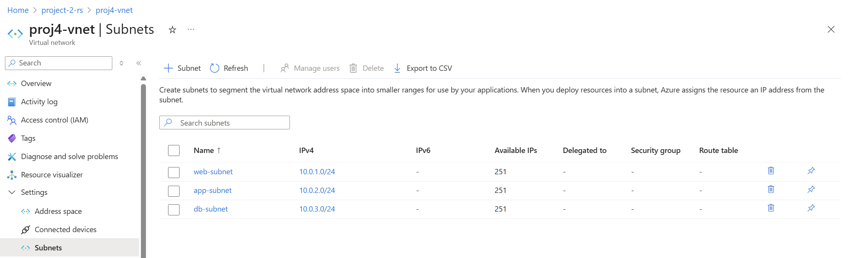

Step 3: Deploy Virtual Machines
Create three Ubuntu virtual machines, each placed in its respective subnet.
VM Name | Subnet | Role
web-vm | web-subnet | Frontend
app-vm | app-subnet | Application logic
db-vm | db-subnet | Database
Common VM Settings:
- Image: Ubuntu LTS
- Size: Standard B1s / B2s
- Authentication: SSH / Password
- Public IP: Enabled (for lab access)
Purpose:
To simulate a real three-tier application environment.
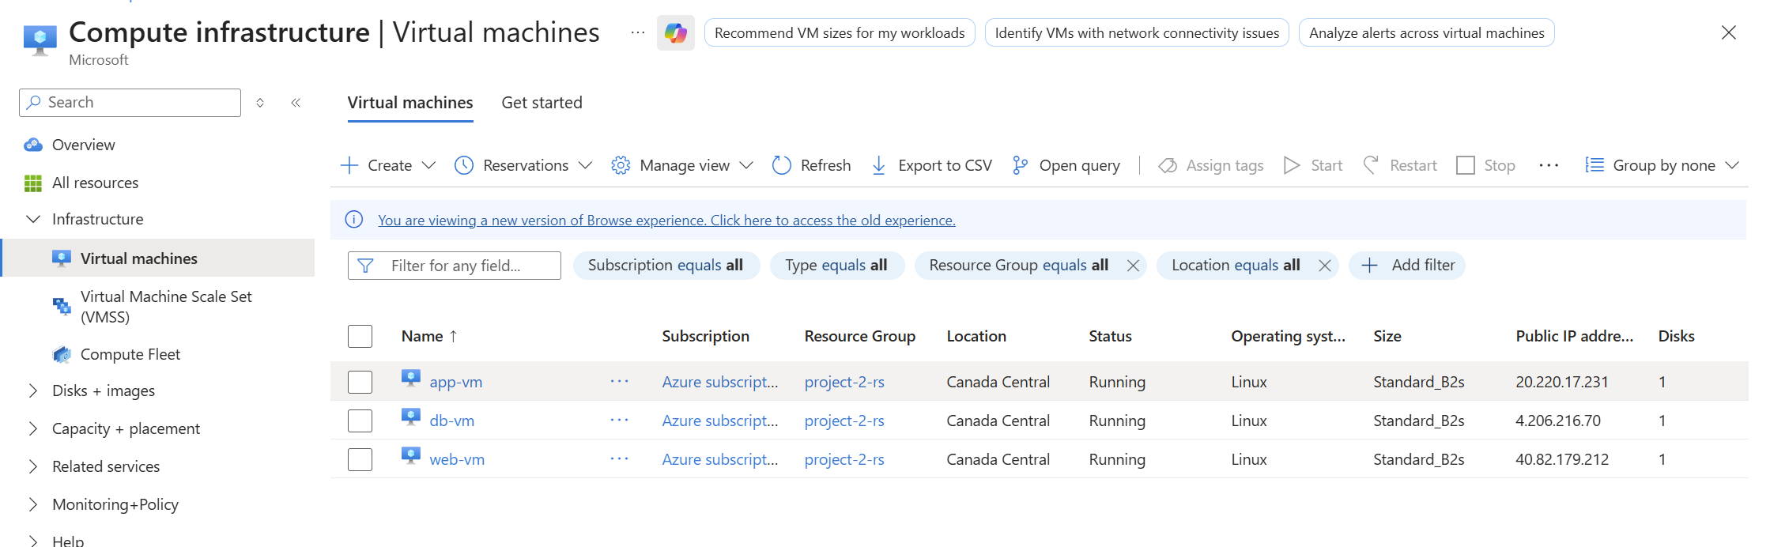

Step 4: Verify VM Connectivity
- SSH into each VM
- Use the following commands:
ping <private-ip-of-other-vm>
- Confirm that all VMs can communicate before applying security rules
Purpose:
To establish a baseline connectivity test.
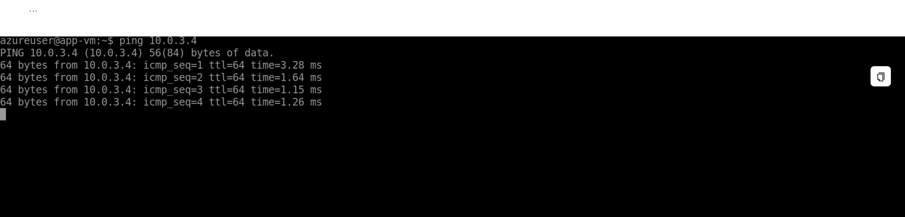

5. Network Security Group (NSG) Configuration

Step 5: Create and Attach NSG
- Go to Network Security Groups → Create
- Name: NetShield-NSG
- Attach the NSG to all three subnets

Step 6: Configure NSG Rules
Allow Web → App Traffic
- Source: Web Subnet
- Destination: App Subnet
- Protocol: Any / TCP
- Action: Allow
Deny Web → DB Traffic
- Source: Web Subnet
- Destination: DB Subnet
- Action: Deny
- Priority: Higher than allow rules
Purpose:
To enforce tier-based communication and block unauthorized access.
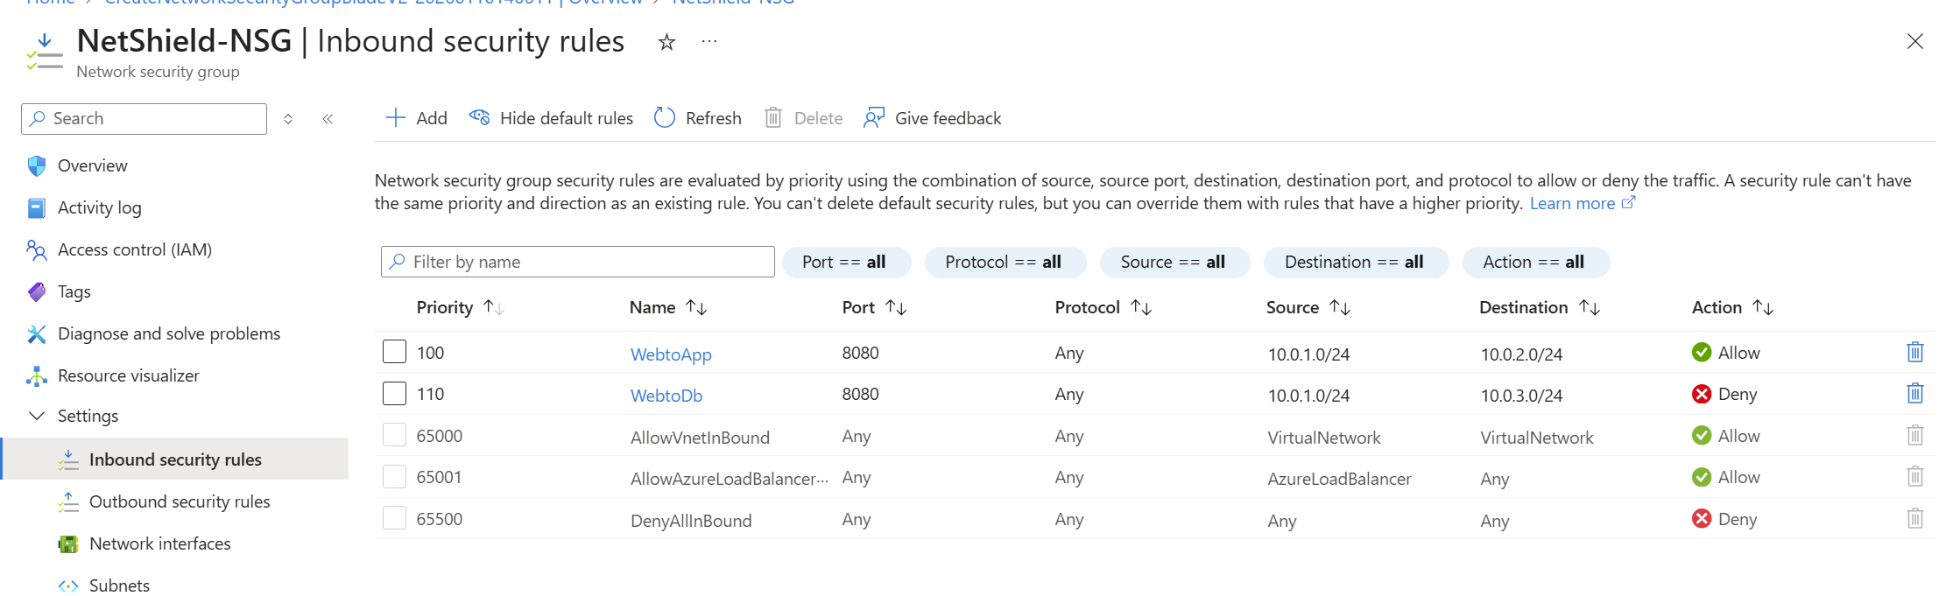

Step 7: NSG Testing
- From web-vm, try:
ping app-vm
ping db-vm
- Expected Result:
- App VM → Reachable
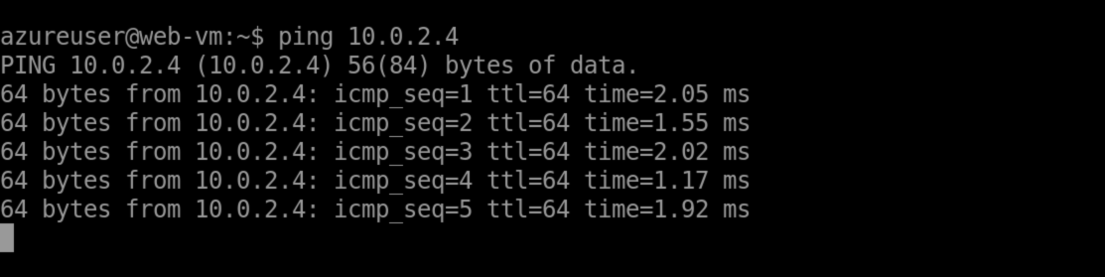
- DB VM → Blocked
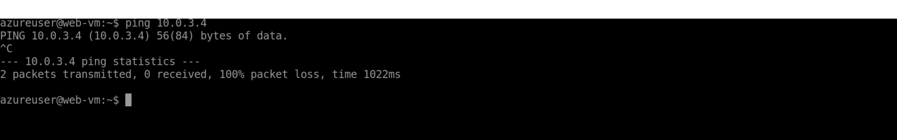

6. Application Security Group (ASG) Configuration

Step 8: Create ASGs
Create two ASGs:
- ASG-Web
- ASG-App
Assign:
- Web VM → ASG-Web
- App VM → ASG-App

Step 9: Configure ASG-based NSG Rule
- Source: ASG-Web
- Destination: ASG-App
- Port: 8080
- Protocol: TCP
- Action: Allow
Purpose:
To manage security using logical groupings instead of IP addresses.
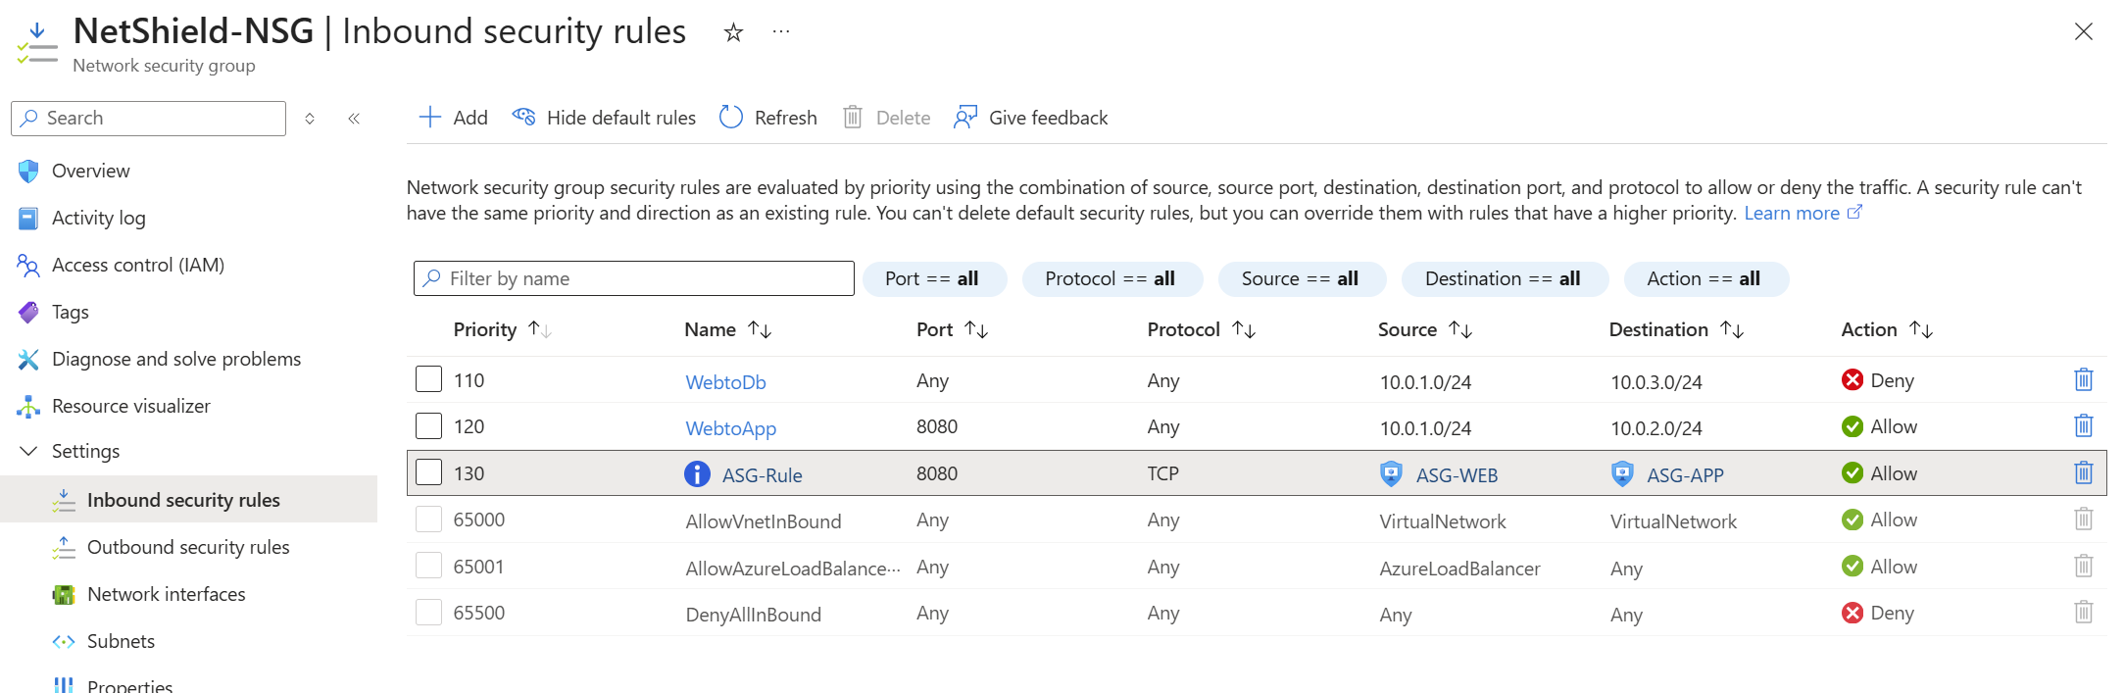

Step 10: ASG Testing
On App VM:
python3 -m http.server 8080
On Web VM:
curl http://<app-vm-private-ip>:8080
Expected Result:
HTML response confirms ASG rule works successfully.
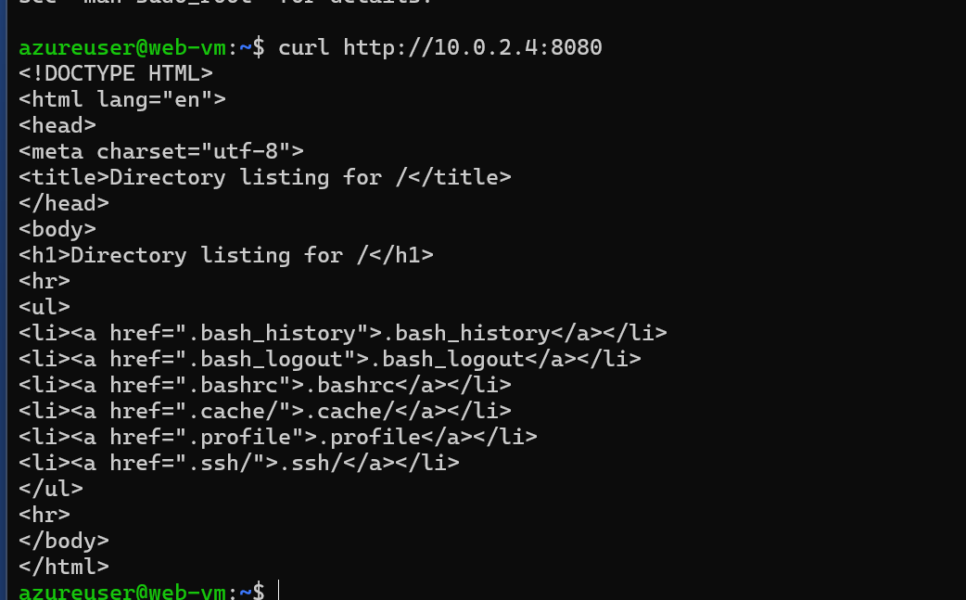

7. Monitoring and Alerting

Step 11: Generate Load on DB VM
- SSH into DB VM
- Run:
sudo apt install stress -y
stress --cpu 2 --timeout 300

Step 12: Configure CPU Alert
- Go to Azure Monitor → Alerts
- Create Alert Rule:
  - Resource: DB VM
  - Condition: CPU > 60%
  - Evaluation Frequency: 1 min
  - Action Group: Email (Gmail)
Purpose:
To detect abnormal CPU usage and notify administrators.
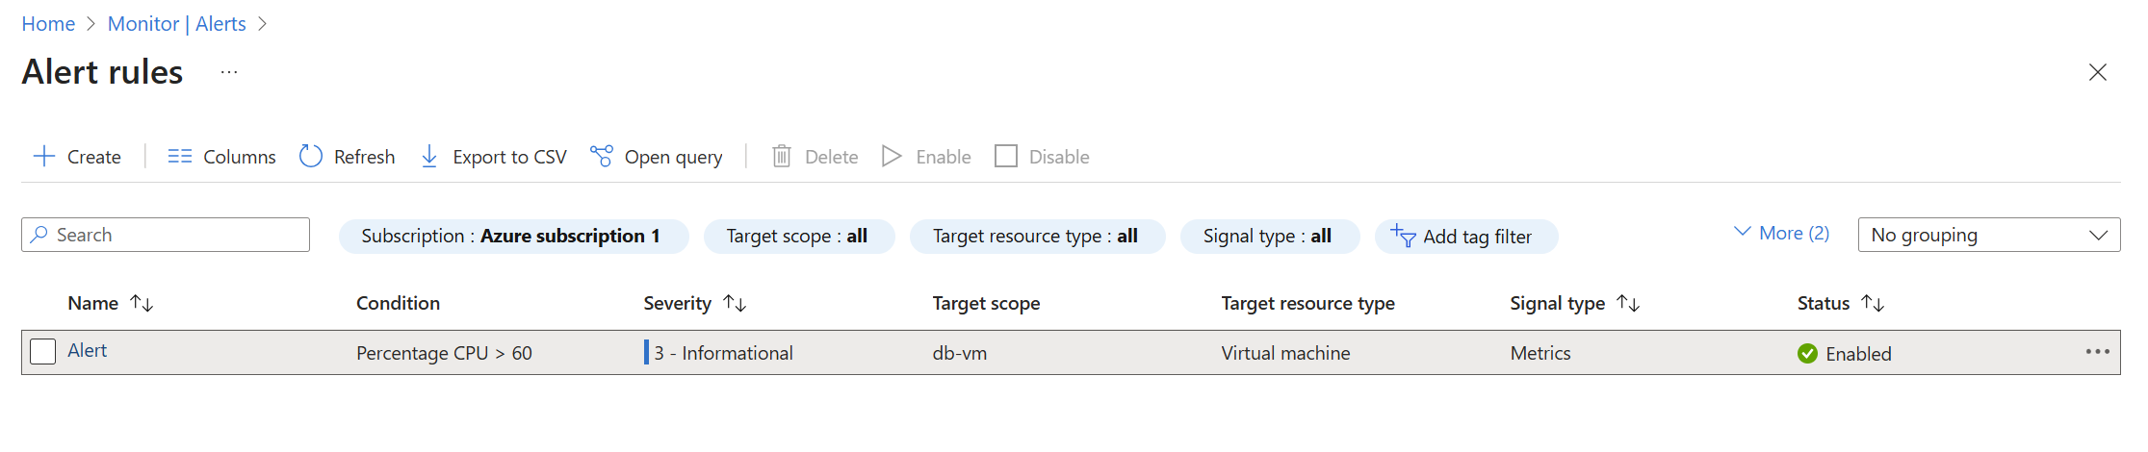

Step 13: Monitor Metrics and Logs
- View:
  - CPU Percentage
  - Network In/Out
  - Disk activity
- Analyze:
  - Activity Logs
  - Diagnostic Logs
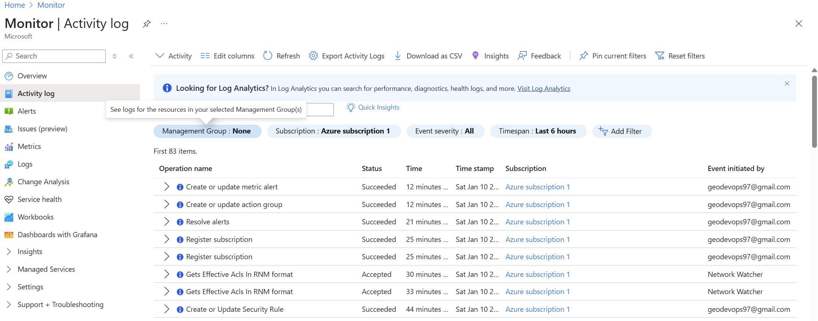
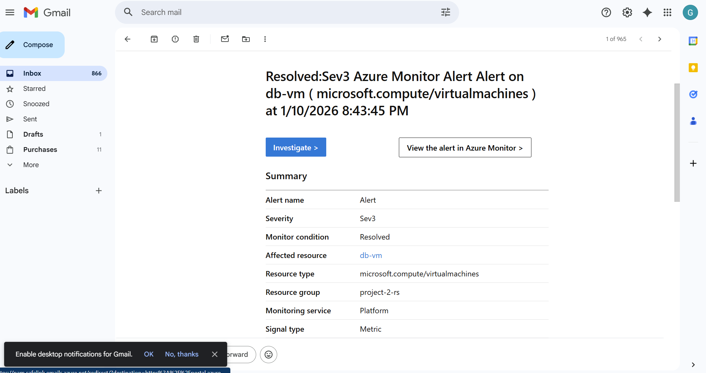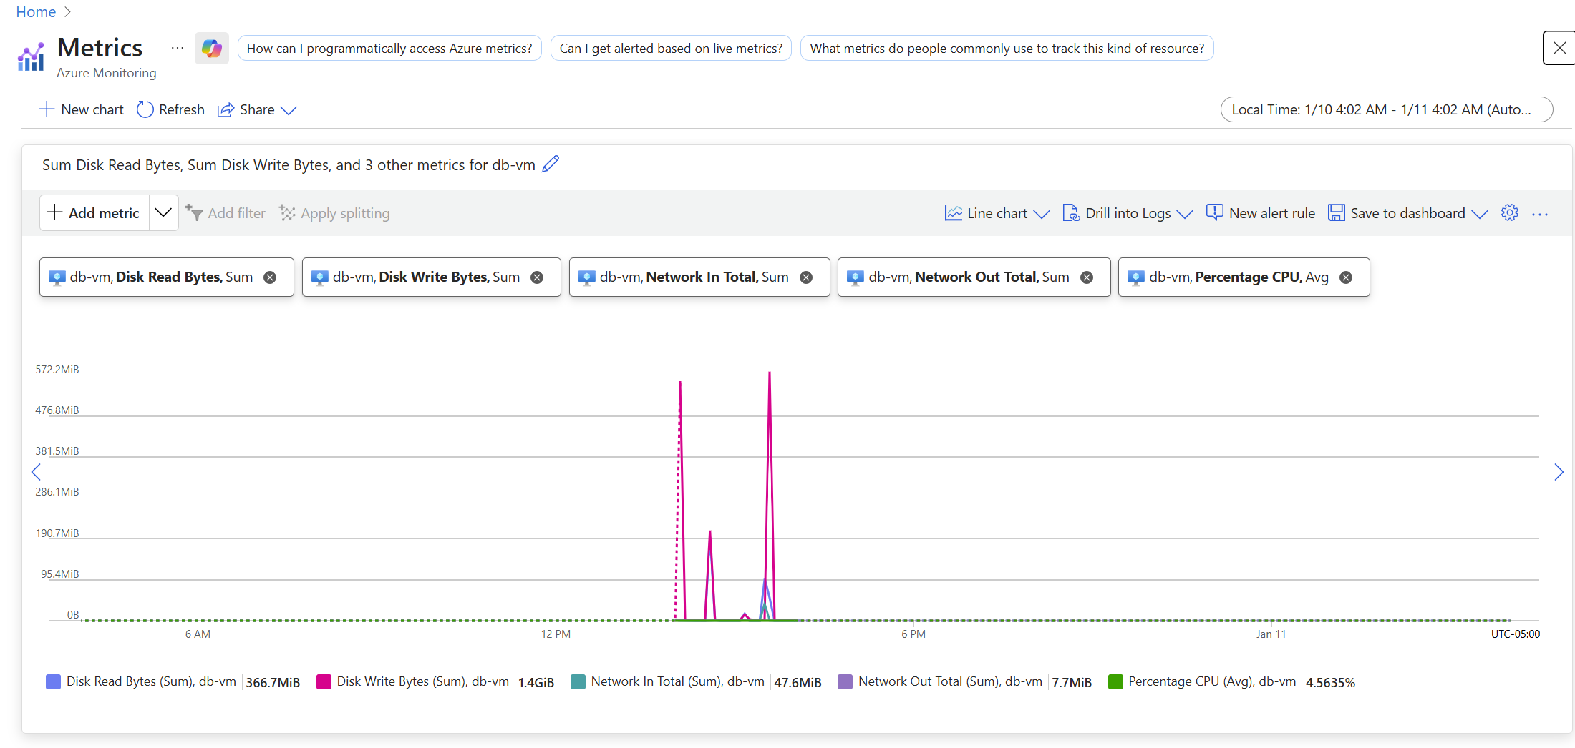

8. Conclusion
The NetShield project successfully demonstrates a secure, enterprise-grade multi-tier architecture using Azure-native security services. By combining NSGs for subnet-level control and ASGs for application-level abstraction, the project highlights best practices in cloud network security.
Key outcomes:
- Implemented strict tier isolation
- Prevented unauthorized lateral movement
- Simplified rule management using ASGs
- Enabled proactive monitoring and alerting
- Gained hands-on experience with Azure security tools
This architecture can be easily extended to real-world production environments and serves as a strong foundation for cloud security design.

9. Skills Acquired
- Azure Virtual Networking
- Network Security Groups (NSG)
- Application Security Groups (ASG)
- Secure Cloud Architecture Design
- Linux VM Administration
- Azure Monitoring & Alerts

10 Architectural Diagram
